
Green University of Bangladesh
Department of Computer Science and Engineering(CSE)
Faculty of Sciences and Engineering
Semester: (Spring, Year:2024), B.Sc. in CSE (Day)

LAB ASSIGNMENT NO #01
Course Title: Data Communication Lab
Course Code: CSE 308 Section: 221_D3

Experiment Name: Implementing Byte Stuffing and De-stuffing

Student Details

Name |  | ID
1. | Jahidul Islam | 221002504

Lab Date : 02 – 03 – 2024
Submission Date : 16 – 03 – 2024
Course Teacher’s Name : Sakhaouth Hossan

[For Teachers use only: Don’t Write Anything inside this box]

Lab Report Status
Marks: ………………………………… Signature:.....................
Comments:.............................................. Date:..............................

1. TITLE OF THE LAB EXPERIMENT:

Implementing Byte (Character) Stuffing and De-stuffing

2. OBJECTIVES:

After complementing this lab experiment, we will gain practical knowledge and tthe outcomes of this experiment are
- To implement the data link layer framing method Character stuffing.

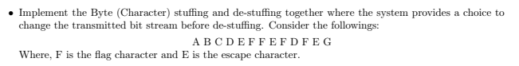

3. PROCEDURE:

First we code to stuff byte
Then again coded to destuff that input

Lastly, combined both code to implement both in a single code.

Two function for stuff and desufff byte..

byteStuffing()

byteDestuffing()

4. IMPLEMENTATION

De-stuffing code:

// Bismillahir Rahmanir Rahim
// jahidulZaid
//

#include <bits/stdc++.h>
using namespace std;
#define optimize() ios_base::sync_with_stdio(0);cin.tie(0);cout.tie(0);
#define endl '\n'
#define tt long long t; cin >> t;
#define ll long long
#define pb push_back

// #ifdef LOCAL
// #include "debug.h"
// #endif

// #ifdef ONLINE_JUDGE
// #include "debug.h"
// #endif

string byteStuffing(const string& input, char flag, char escape) {
string stuffed;
for (char ch : input) {
if (ch == flag || ch == escape) {
stuffed += escape;
}
stuffed += ch;
}
return stuffed;
}

string byteDestuffing(const string& input, char escape) {
string destuffed;
bool prevEscape = false;
for (char ch : input) {
if (ch == escape && !prevEscape) {
prevEscape = true;
} else {
destuffed += ch;
prevEscape = false;
}
}
return destuffed;
}

int main() {
char flag = 'F';
char escape = 'E';

string input;
getline(cin, input);

// stuffing
string stuffed = byteStuffing(input, flag, escape);
cout << "Byte stuffing: " << endl;
cout << stuffed << endl;
cout << endl;
// De-stuffing
string destuffed = byteDestuffing(stuffed, escape);
cout << "Byte destuffing: " << endl;
cout << destuffed << endl;

return 0;
}

5. OUTPUT

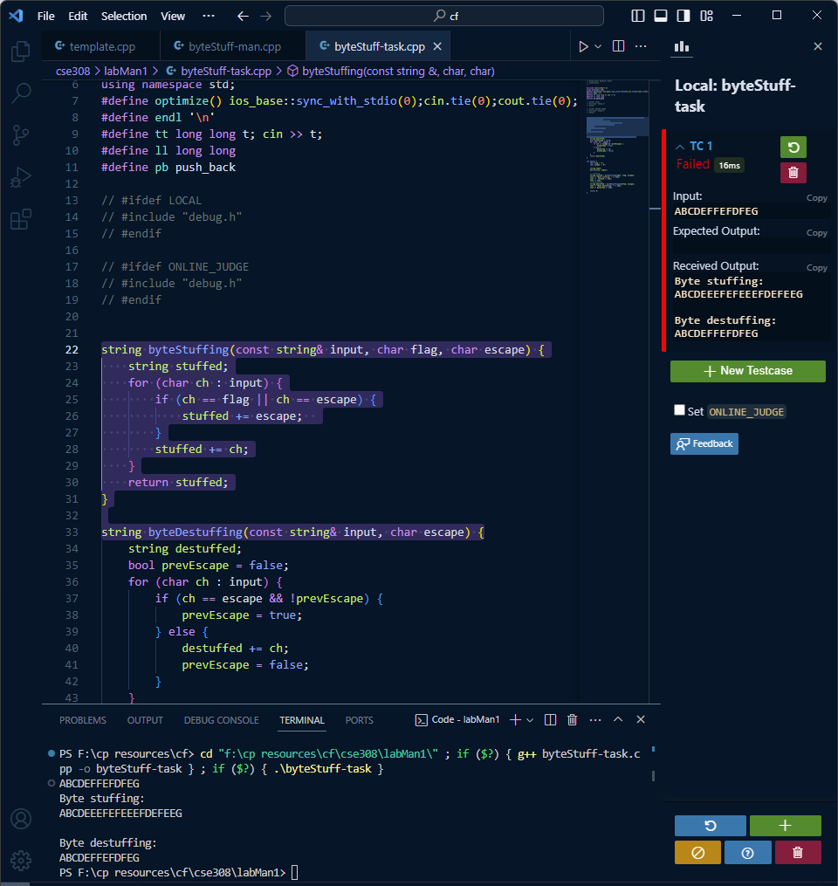

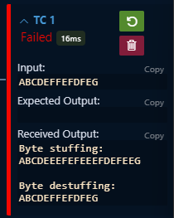
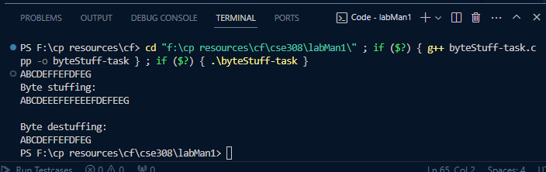

6. ANALYSIS AND DISCUSSION:

After following the above steps we successfully obtained the desired results.

7. SUMMARY:

